**Module 1: Effective Communication**

**Task:** Write professional emails based on any 5 of the following scenarios. Ensure clarity, conciseness, and a formal tone.

1. **Thank you Email.**

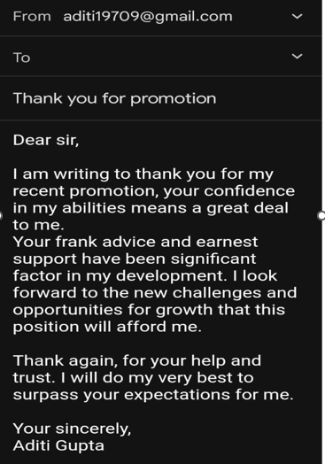

1. **Letter of Apology**

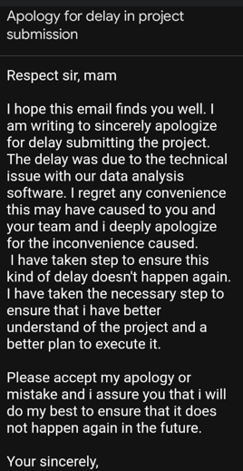

1. **Email of inquiry for requesting information**

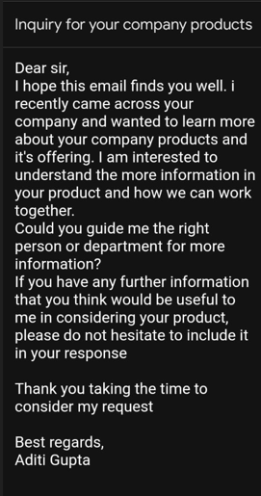

1. **Asking for a Raise in Salary**

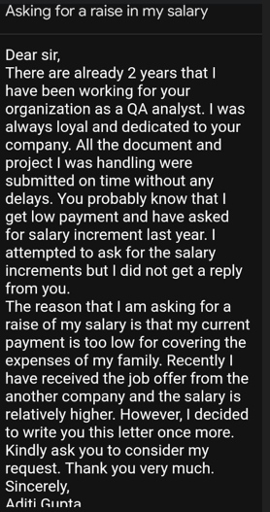

1. **Resignation Email**

